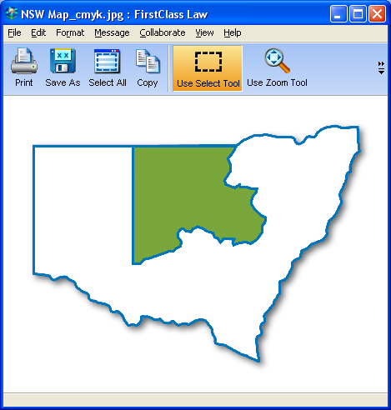

Position Description

Position: FLFV Solicitor | Location: Dubbo

Award: Social, Community, Home Care and Disability Award 2010 (SCHADS)

Status: Temporary, full time 35 hours per week until 30 June 2023.

Work Hours: 9am to 4.30pm (30 min lunch break)

Salary: As per SCHADS Award Grade 5 +5%. Fringe benefits packaging available

Conditions: Probationary period six (6) months

Responsible to: Principal Solicitor, Executive Officer, Management Committee

Overview

Western NSW Community Legal Centre (WNSWCLC) is a not-for-profit non-government organisation with a community led volunteer Management Committee (the Committee). It was established in 1996 after identifying a gap in access to legal services for female victims of crimes; in particular domestic and family violence. Over 20 years the centre has built up a legal delivery program that sees it helping disadvantaged people across a large region. It employs a number of staff who work in a collaborative and respectful team environment. It is based in Dubbo NSW but outreaches monthly to numerous communities including Nyngan, Bourke, Brewarrina, Cobar, Walgett, Lightning Ridge and Coonamble.

WNSWCLC also provides a specific domestic violence legal and casework service to female victims of family and domestic violence. This is known as the Domestic Violence Unit (the DVU). This service employs solicitors and caseworkers who provide legal and non-legal holistic help to its clients.

WNSWCLC promotes access to justice:

- For people within its region who are disadvantaged by their social, cultural and economic circumstances by providing free, accessible and high quality legal services.
- By conducting law reform and community legal education.

The FLFV Solicitor (the Solicitor) is accountable as follows:
- The Principal Solicitor;
- The Executive Officer; and finally
- The Management Committee.

The solicitor will be patient, understanding, non-judgemental and compassionate when helping clients.

Role Summary

This position will involve legal and other work contributing to the day-to-day functioning of the Centre. It will include the provision of legal information, advice, representation and referrals. The role may also include designing and conducting community legal education programs aimed at informing and empowering people in rural and remote areas. The role will also include activities in the area of law reform.

This position will give assistance to victims of family or domestic violence, as well as provide family law assistance to parents and other relevant family or associated members. The solicitor will work closely with other legal and non-legal staff of the centre.

The solicitor is to approach their work and discussions with clients from a whole of person perspective. That is, they are to be sensitive to the client’s personal circumstances and vulnerability and will be mindful, respectful and acknowledging of the client’s situation. Clients are encouraged to have support people with them when attending the service and, where possible, re-traumatisation is to be avoided. Allowing clients to have a voice and be in control of the process and decision-making is critical.

Whilst identifying and focusing on legal issues is critical, it is to be done in the context of letting the client tell their story without fear of judgement. Where possible, clients are not to be rushed. The solicitor will always be mindful to ensure advice is communicated as simply and plainly as possible and will always keep their mind open to identifying non-legal issues for the client which could benefit from non-legal assistance, whether it be from within or outside of the Centre.

Duties and Responsibilities

- Conduct advice, casework and representation
  - The solicitor will provide legal assistance across a range of areas of law such as:
family law, domestic violence/AVO, victims compensation, debt, social security, care and protection, anti-discrimination and employment law.
  - Appear in court for AVO and Recovery Order matters where required and subject to Principal Solicitor approval
  - Appear at mediation and dispute resolution conferences for family law and care and protection matters
  - Identify legal issues and give high quality legal advice to clients
  - Provide advice either face to face or over the phone
  - Undertake ongoing casework for clients
  - Undertake outreach trips, including overnight stays, to conduct client work

- Participate in law reform activities
  - Identify systemic legal issues leading to injustice for disadvantaged people requiring law reform
  - Undertake drafting law reforms submissions to parliamentary enquiries, either on behalf of the centre or as part of a project with other services, including community legal centres.

- File management
  - Conduct regular file review of ongoing casework
  - Attend regular casework meetings
  - Comply with relevant casework and file management policies and procedures

- Community Legal Education
  - Participate in conducting community legal education to community groups
  - Identify the need for community legal education in communities
  - Prepare community legal education sessions on relevant areas of law for community groups
  - Obtain feedback from community legal education sessions via feedback forms
  - Undertake outreach trips, including overnight stays, to conduct community legal education

- Networking and training
  - Liaise with other community service based and government organisations to establish referral pathways for clients between services
  - Establish relationships with other legal practitioners in the region, including Legal Aid and Aboriginal Legal Service
  - Build relationships with other community legal centres and pro bono law firms, such as Ashurst and Gilbert + Tobin
  - Attend the National Association for Community Legal Centre’s National Conference as required
  - Attend CLCNSW Quarterly Meetings in Sydney as required
  - Undertake continuing professional development to obtain 10 CPD points each year

- General
  - Commitment through action and behaviour to WNSWCLC values
  - Comply with WNSWCLC policies and procedures
  - Work cooperatively as part of a multi-disciplinary team
  - Contribute as required to the development, implementation and updating of WNSWCLC policies and procedures
  - Collection of data and prepare reports in accordance with the requirement of Western NSW Community Legal Centre Inc and the funding body
  - Preparation of monthly reports to Management Committee
  - Attend staff meetings and policy and planning days
h. Assist in the general administration of the centre (eg answer the phone, make client appointments etc)
i. Undertake client work on behalf of other solicitors during periods of leave
j. Travel independently or with other staff to rural and remote areas of Orana and North-Western NSW, including correctional centres, and Sydney, involving overnight stay
k. Undertake other duties as required from time to time

…………………………………….. ………………………………….
Employee Executive officer

Date ……………………………. Date……………………………….

Selection Criteria

- Demonstrated understanding of, and commitment to, social justice issues affecting disadvantaged people experiencing economic, social, cultural and geographic disadvantage and a lack of access to legal services
- Eligible to hold a New South Wales practising certificate
- Demonstrated ability to adopt a whole of person focus in the context of giving legal assistance
- Ability to analyse and relate client’s legal issues to the bigger law reform picture and to initiate responses
- Demonstrated ability to work autonomously, as well as collaboratively, in a team environment and able to work with minimal supervision
- High level oral and written communication skills including ability to work in an electronic environment
- Ability and commitment to travel to remote and rural areas, and Sydney as required, including overnight stays
- Hold a current NSW driver’s licence

This job description may be reviewed from time to time and/or in conjunction with your performance reviews.

